**Unit Test Guider**

Contents

**Unit Test Guider** 1

1 On Host. 2

1.1 Create digital output folder for project. 2

1.2 Create Build Targets option. Right click ‘’unitTest’ folder, 2

1.3 **Write** unit test code. click runWindows, 3

1.4 **Debug**--Configurate Debug/Run Option for digitalOutput. (Run->Configurations.)(Option) 3

1.5 **Debug** --Refresh and Run test. (Option) 4

1.6 --Project Unit Test – makefile. (Option) 5

1.7 Click gcovr, check cover range. 5

2 On Target. 6

2.1 Configurations->new…copy.) Property for project. 6

2.2 Option Add digitalOutput. (Copy digitalInput option, then change path.) 6

2.3 Run on target config: **abs-binary.mk**. （products/） 8

2.4 Run on target. Unit (**Uart 9600**, 8, none, 1, none.) 8

1. On Host.

## Create digital output folder for project.

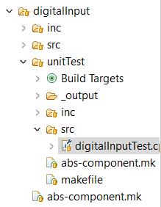

## Create Build Targets option. Right click ‘’unitTest’ folder,

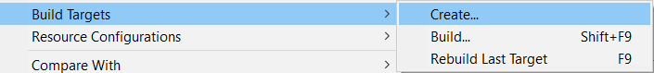

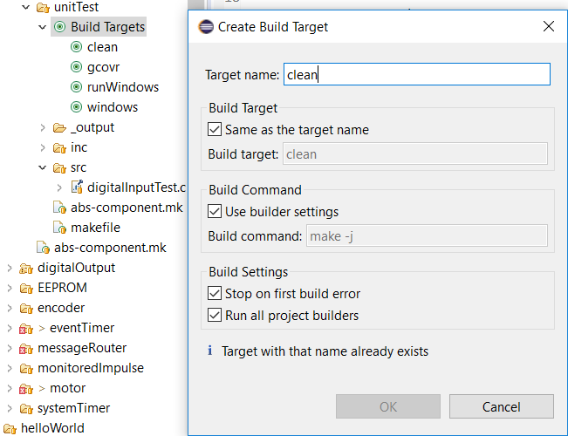

Add new targets: clean, gcovr, runWindows, windows.

## **Write** unit test code. click runWindows,

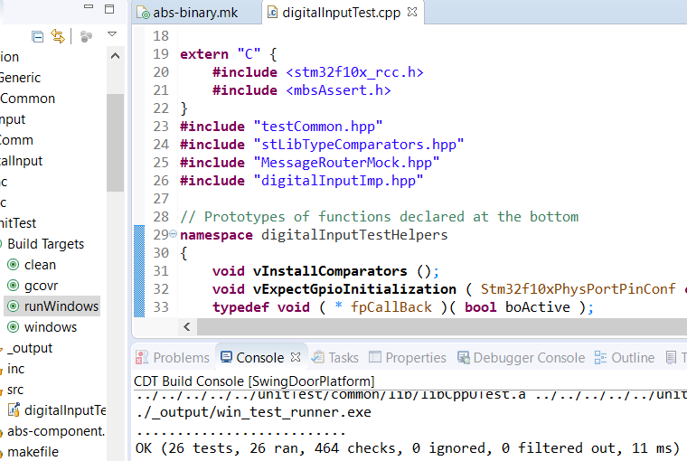

## **Debug**--Configurate Debug/Run Option for digitalOutput. (Run->Configurations.)(Option)

Name : SwingDoorPlatform digitalOutput

Add **C/C++ Unit item**

-> **Main** : C:\mbs\SwingDoorPlatform\components\application

\aaesGeneric\digitalOutput\unitTest\_output\win_test_runner.exe

->**C/C++ Testing** : CppUTest Tests Runner.

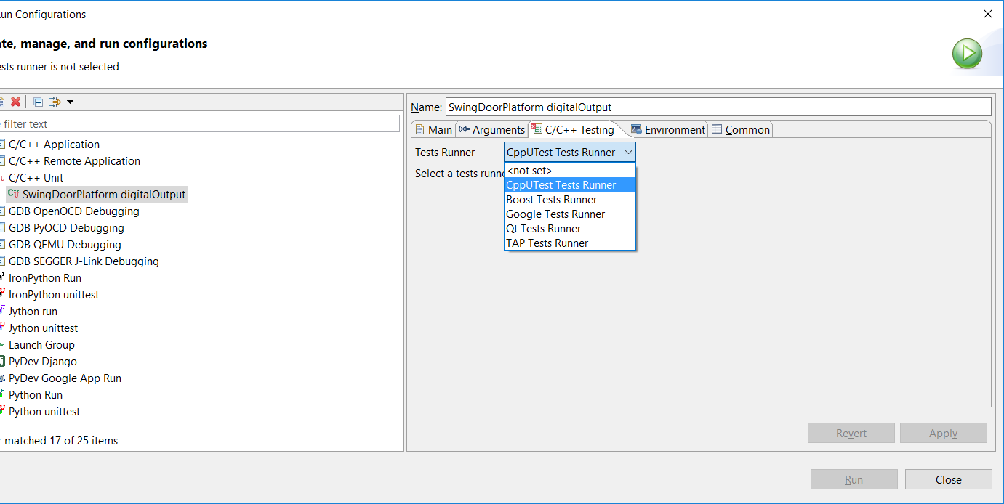

## **Debug** --Refresh and Run test. (Option)

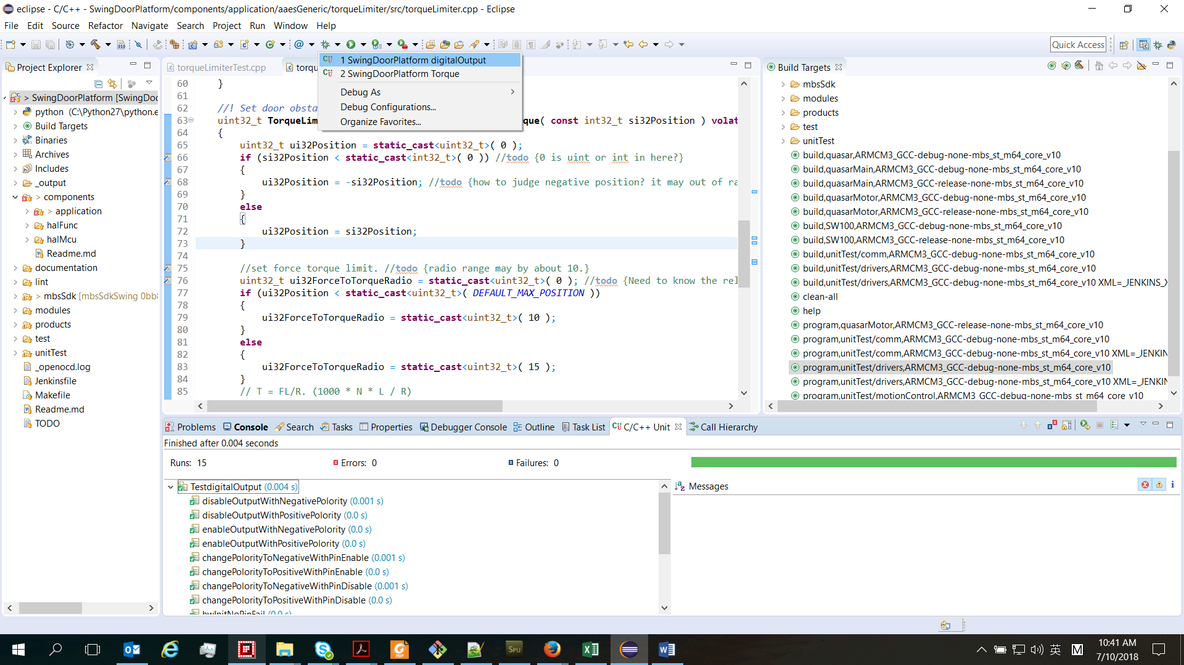

In this setting, you can set breakpoints for unit test debugging.

## --Project Unit Test – makefile. (Option)

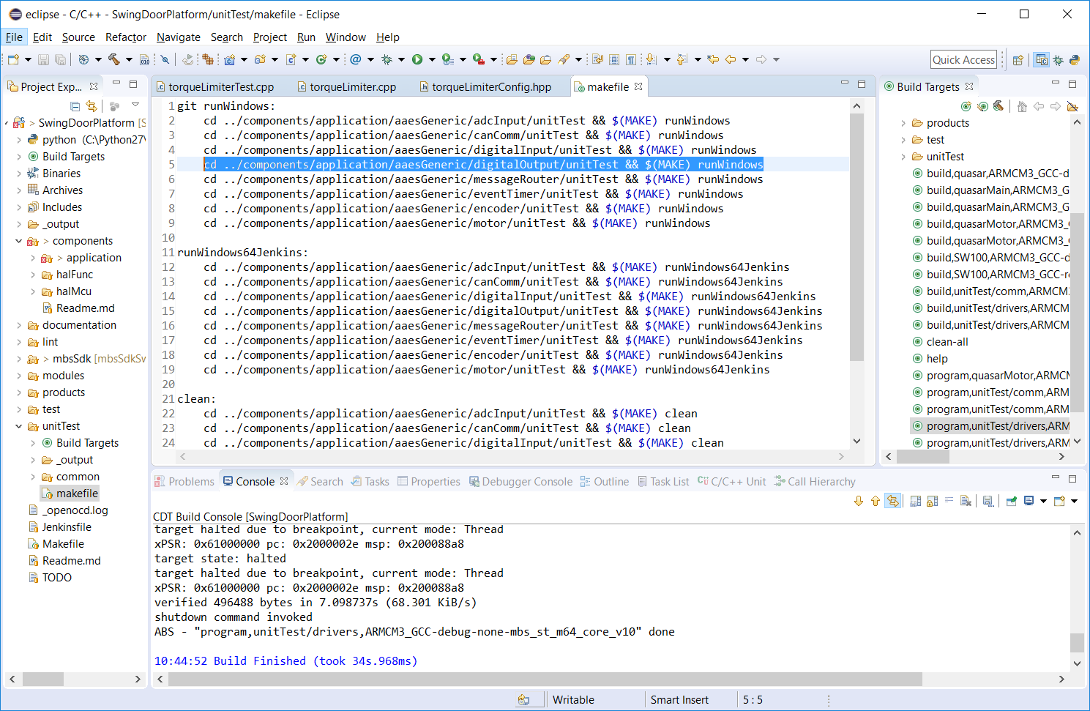

cd ../components/application/aaesGeneric/digitalOutput/unitTest && $(MAKE) runWindows (runWindows64Jenkins, clean)

C:\mbs\SwingDoorPlatform\components\application\swingDoorGeneric\torqueLimiter\

**include** mbsSdk/tools/ABS/abs.mk

make –j help :: /SwingDoorPlatform/mbsSdk/tools/ABS/abs.mk

ABS - making product "products/unitTest/drivers", configuration:

_output/products-unitTest-drivers/ARMCM3_GCC-debug-none-mbs_st_m64_core_v10/products-unitTest-drivers.elf_cache

## Click gcovr, check cover range.

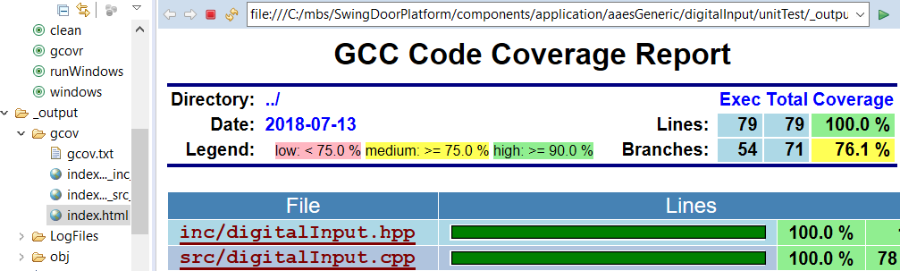

1. On Target.

## Configurations->new…copy.) Property for project.

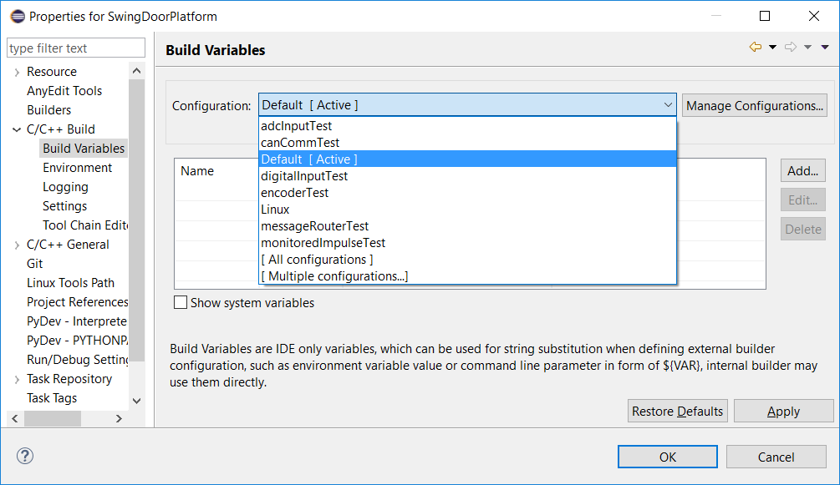

## Option Add digitalOutput. (Copy digitalInput option, then change path.)

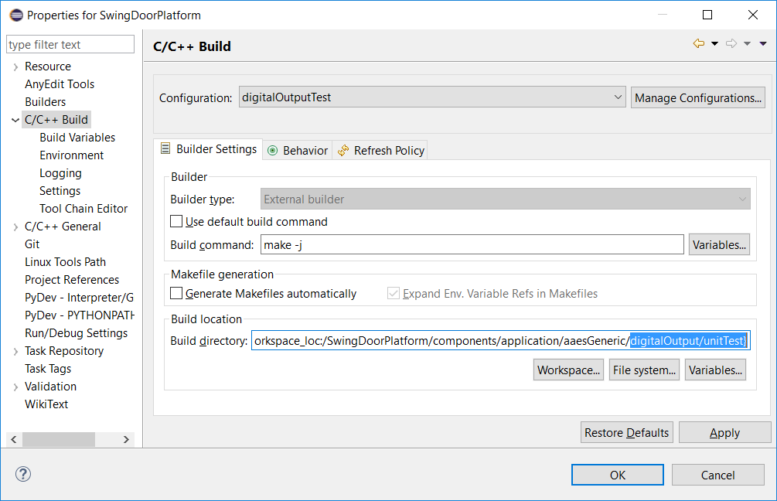

Check compiler toolchain setting.

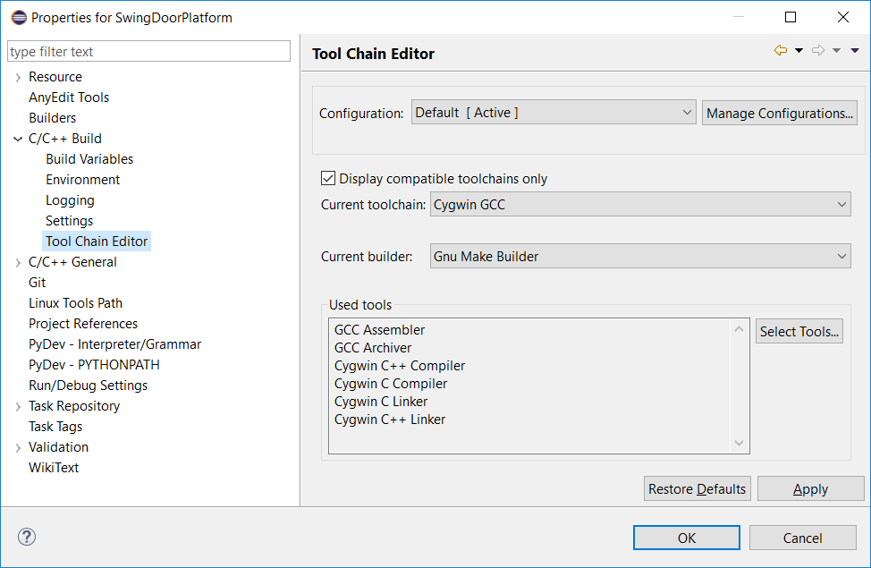

## Run on target config: **abs-binary.mk**. （products/）

/SwingDoorPlatform/**products/unitTest/drivers/abs-binary.mk**

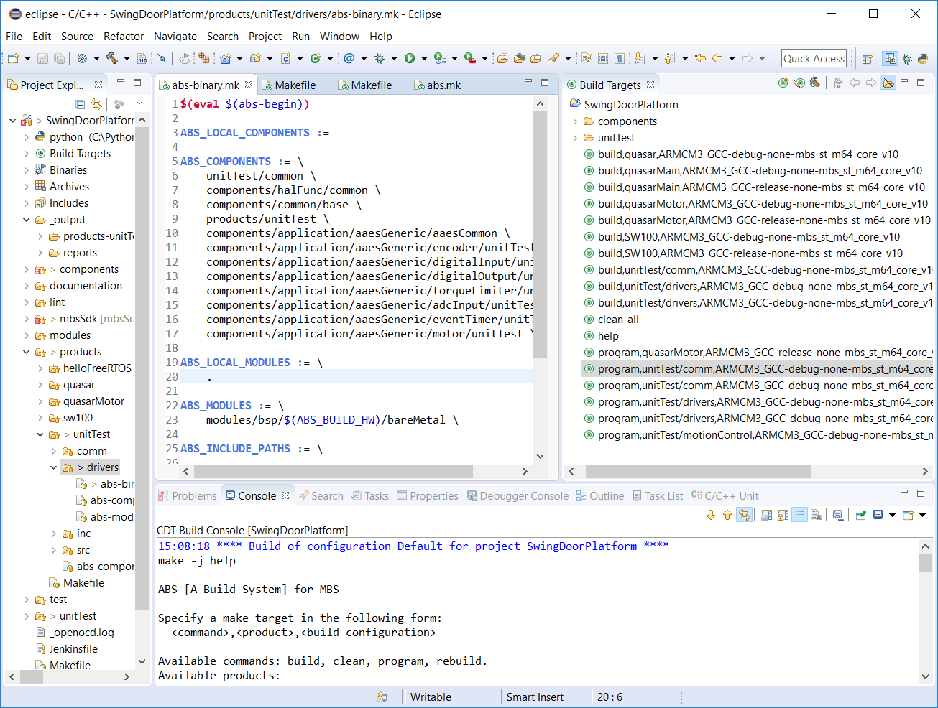

For unitTest/drivers/.. folder, it has built option “program,unitTest/drivers, …”. Add new component in abs-binary.mk file.

/c/mbs/SwingDoorPlatform/products/unitTest/drivers/abs-binary.mk

## Run on target. Unit (**Uart 9600**, 8, none, 1, none.)

Connect board and uart comm, program, and test.

